**Name: Muhammad Zeeshan**

**Roll No: 064**

**Section: BSAI-4B**

**Code:**

**def is_safe(board, row, col, n):**

**for i in range(row):**

**if board[i][col] == 'Q':**

**return False**

**i, j = row - 1, col - 1**

**while i >= 0 and j >= 0:**

**if board[i][j] == 'Q':**

**return False**

**i -= 1**

**j -= 1**

**i, j = row - 1, col + 1**

**while i >= 0 and j < n:**

**if board[i][j] == 'Q':**

**return False**

**i -= 1**

**j += 1**

**return True**

**def solve_n_queens(n):**

**board = [['.' for _ in range(n)] for _ in range(n)]**

**result = []**

**def backtrack(row):**

**if row == n:**

**result.append([['.' if cell == '.' else 'Q' for cell in row] for row in board])**

**return**

**for col in range(n):**

**if is_safe(board, row, col, n):**

**board[row][col] = 'Q'**

**backtrack(row + 1)**

**board[row][col] = '.'**

**backtrack(0)**

**return result**

**n = 4**

**solutions = solve_n_queens(n)**

**for solution in solutions:**

**for row in solution:**

**print(''.join(row))**

**print()**

**Output:**

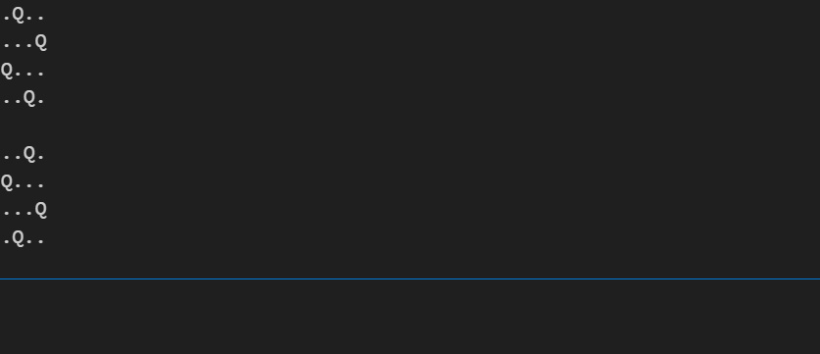

**Explanation**

The N-Queens problem is about placing N queens on an N × N chessboard so that no two queens can attack each other. This program solves the problem using backtracking

Check Safety (is_safe function)  
It ensures that placing a queen at a specific row and column is safe.

It checks the same column, left diagonal, and right diagonal for existing queens.

Solving the Problem (solve_n_queens function)  
It initializes an empty N × N chessboard.

The backtrack function is used to place queens row by row.

Backtracking (backtrack function)

If row == n, it means all queens are placed, so we store the solution.

Otherwise, we try placing a queen in each column of the current row.

If safe, we place the queen ('Q'), move to the next row, and recursively call backtrack.

After returning, we remove the queen ('.') to try another possibility.

Printing the Solutions  
The program runs solve_n_queens(n=4), which finds all valid solutions for a 4×4 board.

It prints each valid board configuration**.**